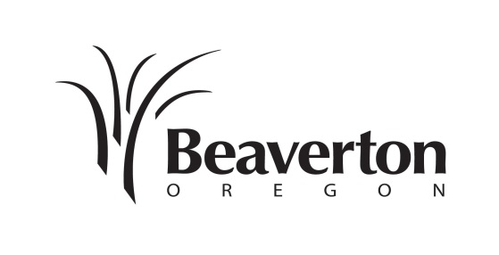
CITY OF BEAVERTON
Community Development Department
Planning Division
12725 SW Millikan Way
PO Box 4755
Beaverton, OR 97076
Tel: (503) 526-2420
Fax: (503) 526-2550
www.beavertonoregon.gov

NOTICE OF PENDING
DIRECTOR’S
INTERPRETATION

Notice Date: January 11, 2018
Project Name: |  | Oregon Beverage Recycling Cooperative (OBRC) Beverage Container Redemption Center (BCRC)  Director’s Interpretation
Case File No: |  | DI2017-0003
Summary of  Application: |  | A Director’s Interpretation is sought as a response to an opinion issued by the Oregon Land Use Board of Appeals (LUBA), which remanded the city’s Design Review decision concerning the property occupied by the applicant, Oregon Beverage Recycling Cooperative (OBRC). In its opinion (LUBA No. 2017-027), LUBA suggests a Director’s Interpretation application, described in Section 40.25.15 of the Beaverton Development Code (BDC), as a means to determine whether the applicant’s Beverage Container Redemption Center (BCRC) is substantially similar to a use listed in BDC Section 20.10 as permitted in the city’s Community Service (CS) zone. The applicant’s BCRC currently operates in the CS zone. The applicant’s BCRC also operates under rules administered by the Oregon Liquor Control Commission (OLCC) and regulations identified in Oregon Revised Statutes (ORS) 459A.737. If the Director finds the BCRC to be substantially similar to a use currently allowed in the CS zone, the decision will clear the way for the earlier Design Review decision issued by the city in case file DR2017-003 for OBRC. That decision was subject to review under separate criteria identified in BDC Section 40.20.15.1.C.
Project Location: |  | The subject site is located on the north side of SW Beaverton-Hillsdale Highway, west of SW 91st Avenue, east of SW 96th Avenue and is addressed as 9307 SW Beaverton-Hillsdale Highway. The project site is also identified as Tax Lot 4100 on Washington County Assessor’s Map 1S1-14AB.
Zoning & NAC: |  | Community Service (CS) / Denney Whitford - Raleigh West NAC
Applicable Code Criteria: |  | BDC Section 40.25.15.1.C Director’s Interpretation approval criteria and Section 10.50 Authorization for Similar Uses.
Staff Contact: |  | Anna Slatinsky at (503) 526-2429 / aslatinsky@beavertonoregon.gov
Interested parties can submit written comments in response to the Director’s Interpretation application. To be considered, the city must receive written comments no later than the codified closing date identified for the Type 2 procedure in BDC Section 50.40. The closing date in this case is February 7, 2018, by 4:30p.m. Mailed written comments in response to this proposal should be sent to the attention of Anna Slatinsky, Planning Division Manager, City of Beaverton, Community Development Department, 12725 SW Millikan Way or P.O. Box 4755, Beaverton, OR 97076. Please reference the Case File Number and Project Name in your written comments.

No public hearing is scheduled for this Director’s Interpretation proposal. Shortly after February 7, 2018, the Community Development Director will issue a Notice of Decision in response to the applicable code criteria. The Director’s decision may be viewed at:
http://apps.beavertonoregon.gov/DevelopmentProjects

A copy of the pre-application conference notes, documents and evidence submitted by or on behalf of the applicant, and applicable review criteria, are available for inspection at the Beaverton Planning Division, 4th floor, Beaverton Building, 12725 SW Millikan Way, between the hours of 7:30 a.m. and 4:30 p.m. Monday through Friday, except holidays.

Failure to raise an issue or failure to provide statements or evidence with sufficient specificity to afford the decision-making authority an opportunity to respond to such issue, may preclude appeal to the Land Use Board of Appeals on that issue.

Accessibility information: This information can be made available in large print or audio tape upon request. Assistive listening devices, sign language interpreters, or qualified bilingual interpreters can be made with advance notice. To request these services, contact by calling 711 (503) 526-2429 or email aslatinsky@beavertonoregon.gov.

